Instructions for Typesetting Manuscripts
Using MS-Word
First Author
University Department, University Name, Address
City, State ZIP/Zone, Country
Second Author
Group, Laboratory, Address
City, State ZIP/Zone, Country
E-mail: first_author@university.com, second_author@university.com
www.university_name.edu

(leave space here should be 4 lines between www.university_name.edu and Abstract)

Abstract
The abstract should summarize the context, content and conclusions of the paper in less than 80 words. It should not contain any references or displayed equations. Typeset the abstract in 9 pt Times Roman with interline space of 11 pt, making an indentation of 2.5 pica on the left and right margins.
Keywords: List four to six keywords which characterize the article.

Introduction
Contributions are to be in English. Authors are encouraged to have their contribution checked for grammar. American or British spelling should be used. Abbreviations are allowed but should be spelt out in full when first used. Integers ten and below are to be spelt out. Italicize foreign language phrases (e.g., Latin, French).

The Main Text
The text is to be typeset in 10 pt Times Roman, single spaced with interline spacing of 13 pt. Text area (excluding running title) is 6.75 inches across and 8.8 inches deep. Final pagination and insertion of running titles will be done by the publisher, so make sure that no page numbers are given in your paper and only the running titles provided in this template (authors’ names and paper title) are used.

Major Headings
Major headings should be typeset in boldface with the first letter of important words capitalized.

Sub-headings
Sub-headings should be typeset in boldface italic and capitalize the first letter of the first word only. Section number to be in boldface Roman.

2.1.1. Sub-subheadings
Typeset sub-subheadings in medium face italic and capitalize the first letter of the first word only. Section numbers to be in Roman.

Numbering and spacing
Please make sure that no page numbers appear in your paper. Sections, sub-sections and sub-subsections are numbered in Arabic. Use double spacing before all section headings and single spacing after section headings. Flush left all paragraphs that follow after section headings.

Running Heads
Please provide a shortened running head (not more than four words, each starting with a Capital) for the title of your paper. This will appear with page numbers on the top right-hand side of your paper on odd pages.

For the running heads for the authors names, please apply the following rules:
- for one author: only the initial plus the full last name (e.g., D. Ruan),
- for two authors: D. Ruan, T. Li,
- for three authors or more: D. Ruan et al.
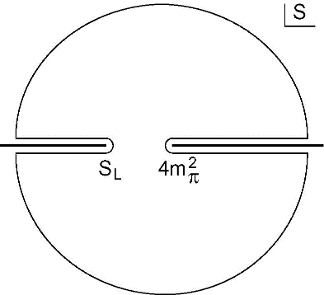
Fig. 1. This is the caption for the figure. If the caption is less than one line then it is centered. Long captions are justified manually.

Lists of items
Lists may be laid out with each item marked by a dot:

- item one,
- item two,
- item three.

Items may also be numbered in lowercase Roman numerals:

- item one
- item three
- Lists within lists can be numbered with lowercase Roman letters,
- second item.

Equations
Displayed equations should be numbered consecutively in each section, with the number set flush right and enclosed in parentheses.
(1)
Equations should be referred to in abbreviated form, e.g., “Eq. (1)” or “(2)”. In multiple-line equations, the number should be given on the last line.
Displayed equations are to be centered on the page width. Standard English letters like x are to appear as x (italicized) in the text if they are used as mathematical symbols. Punctuation marks are used at the end of equations as if they appeared directly in the text.

Theorem 1. Theorems, lemmas, etc. are to be numbered consecutively in the paper. Use double spacing before and after theorems, lemmas, etc.

Proof. Proofs should end with

Illustrations and Photographs
Figures are to be inserted in the text nearest their first reference. Original India ink drawings of glossy prints are preferred. Please send one set of originals with copies. If the author requires the publisher to reduce the figures, ensure that the figures (including letterings and numbers) are large enough to be clearly seen after reduction. If photographs are to be used, only black and white ones are acceptable.
Figures are to be sequentially numbered in Arabic numerals. The caption must be placed below the figure. For those figures with multiple parts which appear on different pages, it is best to place the full caption below the first part, and have e.g., “Fig. 1. (Continued)”' below the last part. Typeset in 9 pt Times Roman with baselineskip of 11 pt. Use double spacing between a caption and the text that follows immediately.
Previously published material must be accompanied by written permission from the author and publisher.

Tables
Tables should be inserted in the text as close to the point of reference as possible. Some space should be left above and below the table. Tables should be numbered sequentially in the text in Arabic numerals. Captions are to be centralized above the tables. Typeset tables and captions in 9 pt Times Roman with baselineskip of 11 pt.
If tables need to extend over to a second page, the continuation of the table should be preceded by a caption, e.g., “Table 2. (Continued)”
Table 1. This is the caption for the table. If the caption is less than one line then it is centered. Long captions are justified to the table width manually.
NP
 |  | 3 | 4 | 8 | 10
 | 3 | 1200 | 2000 | 2500 | 3000
NC | 5 | 2000 | 2200 | 2700 | 3400
 | 8 | 2500 | 2700 | 16000 | 22000
 | 10 | 3000 | 3400 | 22000 | 28000

References
Table 2. The planning and control components.
Schedule | Capacity | Level
Business plan | Financial planning | Planning
Production planning | Resource requirement plan (RRP)
Master production schedule (MPS) | Rough cut capacity plan (RCCP)
Material requirement plan | Capacity requirement plan (CRP)
Final assembly schedule | Capacity control
Stock picking schedule | Inventory control
Order priorities | Factory order control | Execution
Scheduling | Machine (work-centre) control
Operation sequencing | Tool control
 | Preventive maintenance

References in the text are to be numbered consecutively in Arabic numerals, in the order of first appearance. They are to be cited as superscripts without parentheses or brackets after punctuation marks like commas and periods but before punctuation marks like colons, semi-colons and question marks, e.g.,

- “…in the statement.¹”
- “…have proven² that this equation…”

When the reference forms part of the sentence, it should not be typed in superscripts, e.g.,

- “One can deduce from Ref. 3 that…”
- “See Refs. 1–3, 5 and 7 for more details.”

Footnotes
Footnotes should be numbered sequentially in superscript lowercase Roman letters.a

Note Added
Additional note can be added before Acknowledgment.

Acknowledgements
This section should come before the References. Funding information may also be included here.
- Appendices
Appendices should be used only when absolutely necessary. They should come after the References. If there is more than one appendix, number them alphabetically. Number displayed equations occurring in the Appendix in this way, e.g., (A.1), (A.2), etc.
. (A.1)
You must link each References to website as follows.
You must add Authors Introduction as follows

References
- $HYPERLINK "https://www.robocup.org/" “$RoboCup Federation official website,$”$, https://www.robocup.org/
- Y. Yasohara, H. Suzuki, $“$Development of Omni-directional Mobile Mechanism for RoboCup MSL$”$, Proceedings of 31st Fuzzy System Symposium, pp. 151-152, 2015. (In Japanese)
- FLIR, “Flea3(USB3 Vision Camera)”, https://www.flir.com/products/flea3-usb3/
- T. Yoshida, H. Suzuki, $“$Real-Time Self-Localization for RoboCup Middle-Size-League”, Proceedings 32nd Fuzzy System Symposium, pp. 397-398, 2016. (In Japanese)
- D.E.Goldberg, $“$Genetic Algorithms in Search, Optimization and Machine Learning$”$, Addison-Wesley, 1989.
- H. Suzuki, M. Minami, $“$Visual Servoing to Catch Fish Using Global/Local GA Search$”$, IEEE/ASME Transactions on Mechatronics, Vol. 10, No. 3, pp. 352-357, June, 2005.

Authors Introduction

Ms. Kaori Watanabe
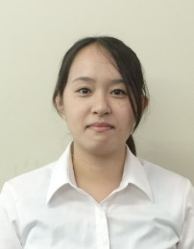
She received her Master's degree from the Department of System Electronics and Information Science, Tokyo Polytechnic University, Japan in 2013. She is currently a Doctoral course student in Tokyo Polytechnic University, Japan.

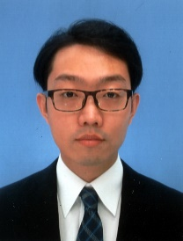
Mr. Yuehang Ma
He received his B.S. degree in Engineering in 2018 from the Faculty of Engineering, Tokyo Polytechnic University in Japan. He is acquiring the M.E. in Tokyo Polytechnic University.

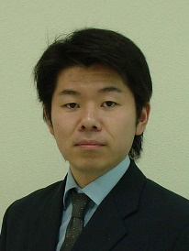
Dr. Hidekazu Suzuki
He is an Associate Professor of Faculty of Engineering at Tokyo Polytechnic University in Japan. He graduated from the Department of Mechanical Engineering, Fukui University, in 2000. He received his D. Eng. degree in System Design Engineering from Fukui University in 2005. His research interest is Robotics.

For the title, try not to use more than 3 lines. Typeset the title in 12 pt Times Roman, uppercase and boldface.
Typeset names in 10 pt Times Roman, uppercase. Use the footnote to indicate the present or permanent address of the author.
a Footnotes should be typeset in 8 pt Times Roman at the bottom of the page.

