PS2

PS2 Biped Robot Research at Waseda University
Kenji Hashimoto, Atsuo Takanishi (Waseda University, Japan)
contact@takanishi.mech.waseda.ac.jp

Waseda University has researched on biped robots since 1967. In this talk I will introduce our latest biped robots, WABIAN-2, a running robot and WL-16. WABIAN-2 has 41-DOF, and its height is 1480 mm with 63.8 kg weight. WABIAN-2 has realized a human-like walk with the knees stretched, heel-contact and toe-off motion by utilizing a foot mechanism having a passive toe joint and a 2-DOF (Roll, Yaw) waist mimicking a human’s pelvis motion. Now we are going to build a new biped humanoid robot capable of running and walking in order to study human running and other features. The running robot can jump by utilizing a pelvic movement and leg elasticity. WL-16 is a human-carrying biped vehicle consisting of two Stewart Platform type legs and waist with a passenger seat. WL-16 can be used as a substitute for a wheel chair. | 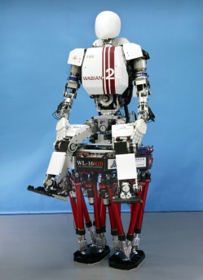

Short Biography of kenji hashimoto
Kenji Hashimoto is an Assistant Professor of the Research Institute for Science and Engineering, Waseda University, Japan. He received the B.E. and M.E. degrees in Mechanical Engineering from Waseda University, Japan, in 2004 and 2006, respectively. He received the Ph.D. degree in Integrative Bioscience and Biomedical Engineering from Waseda University, Japan, in 2009. While a Ph.D. candidate, he was funded by the Japan Society for the Promotion Science as a Research Fellow. He was a Postdoctoral Researcher at the Laboratoire de Physiologie de la Perception et de l'Action in UMR 7152 College de France-CNRS, France from 2012 to 2013. His research interests include walking systems, biped robots, and humanoid robots. He is a member of the IEEE, Robotics Society of Japan (RSJ), Japanese Society of Mechanical Engineers (JSME) and Society of Instrument and Control Engineers (SICE). He received the IEEE Robotics and Automation Society Japan Chapter Young Award in 2006, and the JSME Fellow Award for Outstanding Young Engineers in 2008.

