PS1
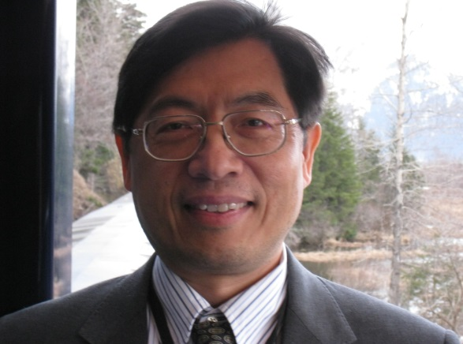

PS1 Vision-Based Grasp Planning and Experiments of a Mobile Manipulator
Yi-Fu Chiu and Kai-Tai Song(National Chiao Tung University, Taiwan)
ivan790721.ece01g@nctu.edu.tw, ktsong@mail.nctu.edu.tw

In this paper, a motion planner is designed and implemented for of a mobile manipulator to travel to a spot for grasping of an object. In this work, the probability of successful grasping inside the workspace of the robot arm is used for grasping planning. A vision SLAM system is combined with reachability calculation to figure out the grasping position. Using a laboratory dual-arm robot, we conducted experiments in different conditions to verify the effectiveness of the developed system. | 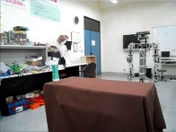

Short Biography of Kai-Tai Song
Kai-Tai Song received his Ph.D. degree in mechanical engineering from Catholic University of Leuven, Belgium in 1989. Since 1989 he has been on the faculty and is currently a Professor in the Department of Electrical and Computer Engineering and Institute of Electrical Control Engineering, National Chiao Tung University(NCTU), Taiwan. He is also currently the Associate Dean of Academic Affairs of NCTU. He served as Associate Dean of the Office of Research & Development of NCTU from 2007 to 2009 and Director of Institute of Electrical Control Engineering from 2009 to 2011. Since 2012, he has been a steering committee member of Asian Control Association(ACA) and currently the VP for publication of ACA. He is a directorate and VP of Chinese Automatic Control Society (CACS); and a directorate of Robotics Society of Taiwan (RST), Taiwan Association of System Science and Engineering(TASSE) and Taiwan Automation Intelligence and Robotics Association(TAIROA). He served as the chairman of the Society of IEEE Robotics and Automation, Taipei Chapter in 1999 and the Program Chair of the 8th Asian Control Conference (ASCC 2011).
He received the best paper in automation award of IEEE ICAL 2012 and best paper in application awards in 2013 and 2014 of CACS International Automatic Control Conference. He received the 2011 Engineering Paper Award, Chinese Institute of Engineers. He received the Distinguished Award in Automatic Control Engineering of Chinese Automatic Control Society(CACS) in 2009 and became a Fellow of CACS in 2010. His current research interests include mobile robots, image processing, visual tracking, mobile manipulation, embedded systems, and mechatronics.

