
Journal of Robotics, Networking and Artificial Life
Vol. 11(2); December (2025), pp. 98-101
ISSN (Online): 2352-6386; ISSN (Print): 2405-9021
https://alife-robotics.org/jrnal.html
Research Article
An Accuracy Evaluation of Multibody Dynamics for the Knee Support Exoskeleton Model with Respect to Implicit Methods for Numerical Integration
Ichiro Tanaka¹, Jiro Suzuki¹, Saburo Watanabe^{2*}
¹Faculty of Engineering, Kyushu Institute of Technology, 2-4 Hibikino, Wakamatsu-ku, Kitakyushu, 808-0196, Japan
²Faculty of Engineering, University of Miyazaki, 1-1 Gakuen Kibanadai-NishiMiyazaki, 889-2192, Japan
Email: tanaka@mail.kyutech.jp, suzuki@brain.kyutech.ac.jp, watanabe@miyazaki-u.ac.jp
*Corresponding Author

ARTICLE INFO
Article History
Received 31 October 2023
Accepted 06 August 2024
Keywords
Numerical integration
Multibody dynamics (MBD)
Analysis error
Ordinary differential equation

ABSTRACT
Numerical integration takes an important role to analyze models described by ordinary differential equations and it largely contributes to an assurance of the accuracy in displacement analyses of multibody dynamics if the model consists of several bodies especially with dynamic components such as springs and dampers. Exoskeletal assistive devices require flexible materials for absorbing reaction forces from human joints, which implies an inevitable necessity of an accurate evaluation of elastic effects in the model. In the present study, we introduced implicit methods for numerical integration to analyze the model under the formulation of multibody dynamics and computer experiments demonstrated results from explicit and implicit methods for the numerical integration as a comparison analysis. It can improve a degree of accuracy in inverse dynamics even in the theory of flexible Multibody Dynamics (fMBD).
© 2022 The Author. Published by The Society of Artificial Life and Robotics.
This is an open access article distributed under the CC BY-NC 4.0 license
(http://creativecommons.org/licenses/by-nc/4.0/).

Introduction
For the sake of analyses of kinematics and kinetics that consist of multiple bodies known as the multibody systems, multibody dynamics (MBD) analysis is getting to be the standard method [1], [2], [3], [4], [5]. Thus, the description of ordinary differential equations accompanied with an appropriate numerical integration acts an important role in ensuring accuracy, especially in the displacement analysis of systems, which are incorporating dynamic elements such as spring and damper components [6]. Indeed, flexible materials are of interest for consideration of bodies absorbing and utilizing reaction force. In consideration of human joint models, those factors are inevitable not only for the detailed analysis of the joint mechanisms but also development of exoskeleton type support device which assists human movement. Therefore, it is highly important to reconstruct an accurate computer experiment even with elastic effects in the model. An increase in the number of bodies and elastic components provides a high complexity in MBD analysis, which may cause the numerical error in the computer experiment.
In particular to dynamics analysis with moving bodies, the selection of the numerical integration method is crucial for the realization of the actual dynamics occurring in the real world. It cannot be solved by a simple way to chip the time step of the integration in the explicit numerical method. In the implicit numerical integration, it will help to refine the time step adaptively.
In the present study, we introduced the implicit numerical integration methods under the MBD formulation [7] and evaluate the effect in comparative analysis between results of explicit and implicit solutions of numerical integrations [7], [8], [9]. In this sense, the advantages to utilize the implicit methods can be revealed in the computer experiment, which realizes the necessity and appropriate selection of the numerical method depending on the target system. It will contribute to an actual numerical solution not only for rigid-body mechanics but also for flexible multibody dynamics (fMBD), which embeds the finite element method (FEM) into the original description of MBD.

Methodology

Numerical error under MBD analysis
In MBD-based dynamic analysis, the coordinates and rotation angles of each mechanical element in the analytical system are obtained by solving the second-order ordinary differential equations based on the following differential algebraic equations for the generalized acceleration matrix $\ddot{q}$. The meanings of the characters in Eq. (1) are as Table 1.
$$\left[\begin{matrix}M & Φ_{q}^{T} \\ Φ_{q} & 0\end{matrix}\right]\left[\begin{matrix}\ddot{q} \\ λ\end{matrix}\right]=\left[\begin{matrix}Q^{A} \\ γ\end{matrix}\right]$$ | (1)
Table 1 The planning and control components.
$$M$$ | Mass matrix
$$Φ_{q}$$ | Jacobian matrix differentiated from constraint equation in generalized coordinates
$$\ddot{q}$$ | Generalized acceleration matrix
$$λ$$ | Lagrange multiplier
$$Q^{A}$$ | Generalized force
$$γ$$ | Acceleration equation
In computer analysis, this second-order ordinary differential equation can be solved by numerical integration methods, however errors accumulate at each analysis step. These numerical errors appear in the deviations of nodal coordinates connecting each element in the kinematic analysis, and the accuracy of the numerical integration methods can be evaluated by the distance of the nodal coordinates (Figure 1).
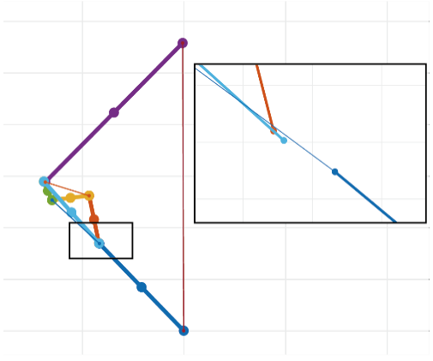
Figure 1 Displacements of the nodal coordinates caused by errors of numerical integration in knee linkage model [6].

Numerical integration methods
In order to compare and verify the analytical errors in the MBD analysis, we applied the numerical integration methods to the dynamic analysis with MBD of single and double pendulums (Figure 2) to simply verify the errors.

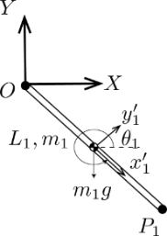 | 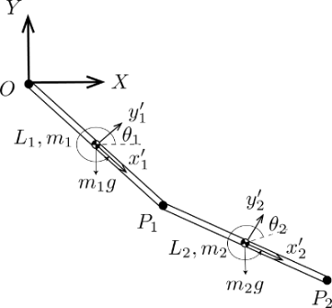
- Single pendulum. | - Double pendulum.
Figure 2 Generalized coordinate systems of pendulums for MBD analysis.
For comparing errors caused by numerical integration methods, we applied Runge-Kutta Gill’s method [10], the two-stage fourth order and the three-stage sixth order implicit Runge-Kutta (IRK) method. Gill’s method is explicit fourth order Runge-Kutta method. The s-stage IRK method is described as the following equation [7], [8]. The coefficients a, b and c in Eq. (2) are due to the Butcher array (Table 2).
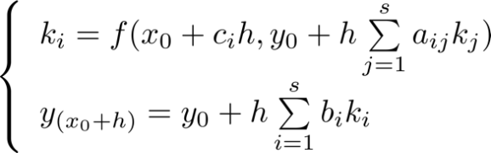 | (2)
Table 2 The Butcher array for IRK.
$$\begin{matrix}c_{1} \\ ⋮ \\ c_{s}\end{matrix}$$ | $$\begin{matrix}a_{11} & ⋯ & a_{1s} \\ ⋮ & ⋱ & ⋮ \\ a_{s1} & ⋯ & a_{ss}\end{matrix}$$
 | $$\begin{matrix}b_{1} & ⋯ & b_{s}\end{matrix}$$
In MBD analysis, since the generalized acceleration matrix $\ddot{q}$ is obtained by solving a second-order ordinary differential equation as Eq. (3), the equations for obtaining the generalized coordinates matrix $q$ and the generalized velocity matrix $\dot{q}$ with IRK are as Eq. (4) and Eq. (5).
$$\ddot{q}=f(t,q,\dot{q})$$ | (3)
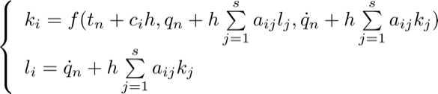  $$(i=1,⋯,s)$$ | (4)
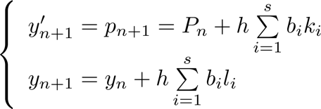 | (5)
Within each integral computation step, the Newton-Raphson method is inserted to find solutions of the simultaneous equations to derive all coefficients $k_{i}$ and $l_{i}$ in Eq. (4), then q and $\dot{q}$ are obtained by Eq. (5). The Butcher arrays for 2stage 4order IRK (Table 3) and 3stage 6order IRK (Table 4) are shown as follows [8].
Table 3 The Butcher array for 2-4 IRK.
$$\begin{matrix}\frac{1}{2}-\frac{\sqrt{3}}{6} \\ \frac{1}{2}+\frac{\sqrt{3}}{6}\end{matrix}$$ | $$\begin{matrix}\frac{1}{4} & \frac{1}{4}-\frac{\sqrt{3}}{6} \\ \frac{1}{4}+\frac{\sqrt{3}}{6} & \frac{1}{4}\end{matrix}$$
 | $$\begin{matrix}\frac{1}{2} & \frac{1}{2}\end{matrix}$$
Table 4 The Butcher array for 3-6 IRK.
$$\begin{matrix}\frac{1}{2}-\frac{\sqrt{15}}{10} \\ \frac{1}{2} \\ \frac{1}{2}+\frac{\sqrt{15}}{10}\end{matrix}$$ | $$\begin{matrix}\frac{5}{36} & \frac{2}{9}+\frac{\sqrt{15}}{15} & \frac{5}{36}+\frac{\sqrt{15}}{30} \\ \frac{5}{36}+\frac{\sqrt{15}}{24} & \frac{2}{9} & \frac{5}{36}-\frac{\sqrt{15}}{24} \\ \frac{5}{36}+\frac{\sqrt{15}}{30} & \frac{2}{9}+\frac{\sqrt{15}}{15} & \frac{5}{36}\end{matrix}$$
 | $$\begin{matrix}\frac{5}{18} & \frac{4}{19} & \frac{5}{18}\end{matrix}$$

Heading 1 Title

Heading 2 Title

Heading 3 Title

Heading 4 Title
Each numerical integration method was implemented in the numerical computation of MBD analysis of single and double pendulums (time increment $h=0.1$), and the calculation errors were verified. The differences in the trajectory by numerical integrations are shown in Figure 3.
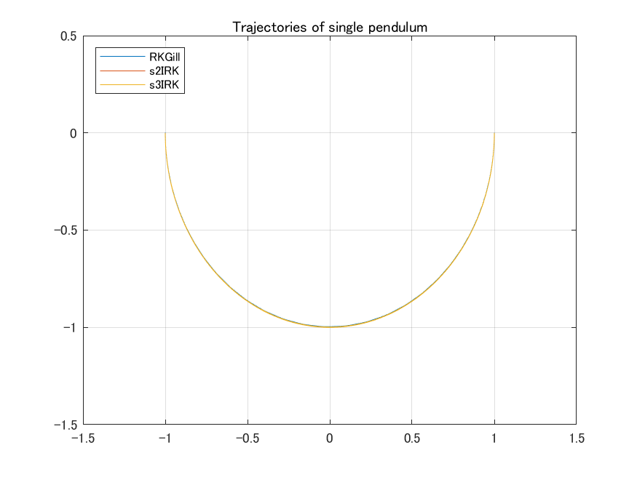
- Single pendulum.
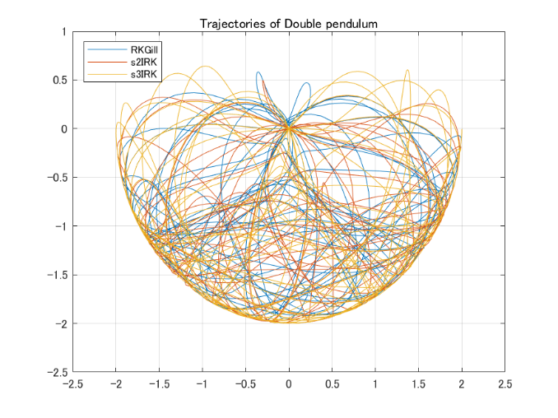
- Double pendulum.
Figure 3 Trajectories of pendulums.

Figure 4 shows the step-by-step transition of the joint coordinate error computed by numerical integrations.
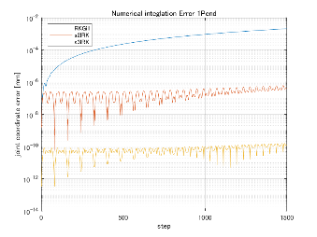
- Single pendulum.
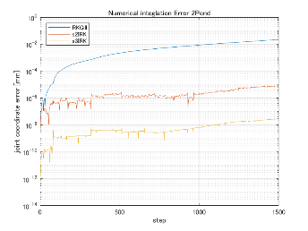
- Double pendulum.
Figure 4 Comparison of coordinate errors by numerical integration method.
According to these figures, the errors in the single and double pendulum are smaller for the implicit solution than for the explicit solution. It is also clear that the analytical error becomes smaller as the order of the numerical integration method increases. Therefore, in the analysis of a system consisting of multiple elements based on MBD, it is possible to evaluate the accuracy of numerical integral calculations from the errors in the joint coordinates of the mechanical elements constituting the system to be analyzed.

Performance of the numerical integration on MBD analysis
In numerical computation, the analytical time is important as analytical accuracy. Figure 5 shows the changes in numerical computation time due to the expansion of the order of the implicit numerical integration and the number of variables in the MBD dynamics analysis of the pendulums. The number of computation steps is 1500.
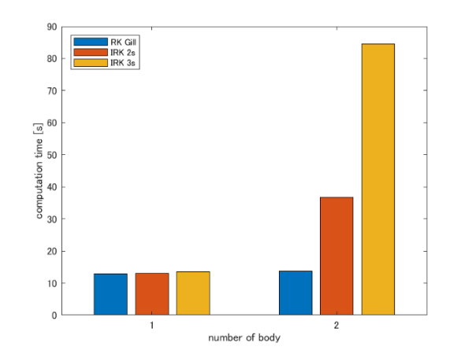
Figure 5 The analysis times of numerical integrations.
The analysis times increase significantly when the number of steps in the implicit integral is expanded. In the implicit method, the solutions of simultaneous equations are obtained by inserted Newton-Raphson method, and numerical substitutions into symbolic matrix within this process require the computation processing time. The symbolic matrix is enlarged by increasing the number of implicit stages, which takes more computation time. Therefore, it is important to implement an efficient substitution process into a symbolic matrix for the implementation of higher order implicit methods in MBD analysis.

Conclusion
The validation of the numerical integration in the pendulum model analysis with MBD shows methods to suppress the error due to the numerical integration of the second-order ordinary differential equations in the kinetic and dynamic analysis with MBD analysis.
In further analysis, these numerical integration methods can be adopted to the dynamics/inverse dynamics of knee joint mechanism and human walking analysis based on fMBD analysis, and comparisons of their analytical accuracy can be discussed. However, there are issues in implementing the higher order IRK to multielement mechanism analysis, such as improving the performance by streamlining the substitution process for symbolic matrix formulas in MATLAB.

Acknowledgements
This work was supported in part by JSPS KAKENHI (16H01616, 17H06383), Project on Regional Revitalization Through Advanced Robotics (Kyushu Institute of Technology/Kitakyushu city, Japan) and Kitakyushu Foundation for the Advancement of Industry, Science and Technology (FAIS). The authors gratefully acknowledge ARIZONO orthopedic supplies Co., Ltd. for assistance with the formulation of exoskeleton-type assistive devices in their products.

References
- J. A. C. Ambrósio, Impact of Rigid and Flexible Multibody Systems: Deformation Description and Contact Models, in Virtual Nonlinear Multibody Systems. NATO ASI Series (Series II: Mathematics, Physics and Chemistry), eds. W. Schiehlen and M. Valášek, Springer, Dordrecht, vol 103, 2003, pp. 57-81.
- P. E. Nikravesh, Planar Multibody Dynamics: Formulation, Programming with MATLAB, and Applications, 2nd edn., CRC Press, Boca Raton, 2018.
- K. Komoda and H. Wagatsuma, Energy-efficacy comparisons and multibody dynamics analyses of legged robots with different closed-loop mechanisms, Multibody System Dynamics 40, 2017, pp. 123–153.
- D. Batbaatar and H. Wagatsuma, A Proposal of the Kinematic Model of the Horse Leg Musculoskeletal System by Using Closed Linkages, Proceedings of the 2019 IEEE International Conference on Robotics and Biomimetics (ROBIO), Dali, China, 2019, pp. 869–874.
- J. Baumgarte, Stabilization of constraints and integrals of motion in dynamical systems, Computer Methods in Applied Mechanics and Engineering 1(1), 1972, pp. 1–16.
- S. Kasai, P. Dachkinov, K. Tanaka and H. Wagatsuma, A MBD-based Knee Link Model to Analyze Singular Postures to Find Necessary Restrictions Toward Personalized Knee Support Exoskeleton, Journal of Robotics, Networking and Artificial Life, Vol. 9(2); September (2022), pp. 128–135.
- M. Iwamura, Introduction to Multibody Dynamics, Morikita Publishing, 2018.
- E. Hairer, S. P. Norsett and G. Wanner, Solving Ordinary Differential Equations Ⅰ, Springer, 1993.
- E. Hairer and G. Wanner, Solving Ordinary Differential Equations Ⅱ, Springer, 1996.
- Wolfram Research, Inc., Runge-Kutta Gill’s method, https://mathworld.wolfram.com/GillsMethod.html

Authors Introduction
Mr. Ichiro Tanaka

He received his Bachelor’s degree in Engineering in 2021 from the Faculty of Engineering, Kyushu Institute of technology in Japan. He is currently a master student in Kyushu Institute of Technology, Japan.

Dr. Jiro Suzuki
He received his Ph.D. degrees from Kyushu University, Japan, in 2001. Currently he is Professor of the Department of Applied Chemistry, Faculty of Engineering, Kyushu Institue of Technology. His current research interests include separation engineering for poorly water-soluble drugs.

Dr. Saburo Watanabe
He received his M.S., and Ph.D. degrees from Tokyo Denki University, Japan, in 1997 and 2005, respectively. In 2009, he joined Miyazaki University, where he is currently an Associate Professor of the Department of Human Intelligence Systems. His research interests include non- linear dynamics and robotics. He is a member of IEEE.

