MESSAGES

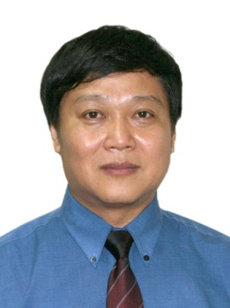  Yingmin Jia  General Chair  (Professor,  Beihang University,  R .P. China) | Yingmin Jia  General Chair of ICAROB  It is my great pleasure to invite you to the International Conference on Artificial Life and Robotics (ICAROB), in Oita City, Oita, Japan from Jan. 11th to 13th, 2014.  ICAROB 2014 develops from the AROB that was created in 1996 by Prof. Masanori Sugisaka and celebrated her birthday of eighteen years old in 2013. Doubtless, new mission and big challenges in the field of artificial life and robotics will promote ICAROB to start a new stage and attract wide interests among scientist, researchers, and engineers around the world.  For a successful meeting, many people have contributed their great efforts to ICAROB. Here, I would like to express my special thanks to all authors and speakers, and the meeting organizing team for their excellent works.  Looking forward to meeting you at ICAROB in Oita City and wishing you enjoy your stay in Japan.

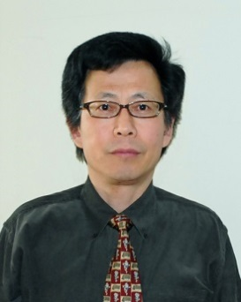  Takao Ito  General Chair  (Professor of Ube National College of Technology  , Japan) | Takao Ito  General Chair of ICAROB  It is my great honor to invite you all to The International Conference on Artificial Life and Robotics (ICAROB 2014).This Conference is changed as the old symposium from the first (1996) to the Eighteenth I am pleased to welcome you to the 2013 International Conference on Artificial Life and Robotics (ICAROB) in the wonderful city of Oita, Japan  The ICAROB has long history. The former organization of the ICAROB was developed under the strong leadership of the President, Professor. Masanori Sugisaka, the father of AROB. We gathered many researchers, faculty members, graduate students from all over the world, and published numerous high-quality proceedings and journals every year.  Over the years, dramatic improvements have been made in the field of artificial life and its applications. The ICAROB has becoming the unifying the exchange of scientific information on the study of man-made systems that exhibit the behavioral characteristic of natural living systems including software, hardware and/or wetware. Our conference shapes the development of artificial life, extending our empirical research beyond the territory circumscribed by life-as-we-know-it and into the domain of life-as-it-could–be. It will provide us a good place to present our new research results, good ideas, and valuable information about artificial intelligence, complex systems theories, robotics, management of technology, etc.  In order to provide an outstanding technical level for the presentations at the conference, we have invited more than 60 distinguished experts in the field of artificial life in the organizing committee and program committee. We will have 23 sessions during 3 days of conference, including 3 invited sessions.  The conference site is the Compal Hall, one of the finest congress centers in Oita. It is situated near the center of the city. You can find many fantastic scenic spots and splendid hot-springs. Enjoy your stay and take your time to visit the city of Oita.  I am looking forward to meeting you in Oita during 2013 ICAROB and to sharing a most pleasant, interesting and fruitful conference

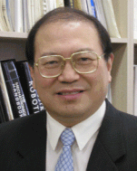  Ju-Jang Lee  General Chair  (Professor, KAIST) | Ju-Jang Lee  General Chair of ICAROB  The First International Conference on Artificial Life and Robotics (ICAROB) will be held in Oita City, Oita, Japan from Jan. 11th to 13th, 2014. This year’s Conference will be held amidst the high expectation of the increasingly important role of the new interdisciplinary paradigm of science and engineering represented by the field of artificial life and robotics that continuously attracts wide interests among scientist, researchers, and engineers around the globe.  Distinguished researchers and technologists from around the world are looking forward to attending and meeting at ICAROB. ICAROB is becoming the annual excellent forum that represents a unique opportunity for the academic and industrial communities to meet and assess the latest developments in this fast growing artificial life and robotics field. ICAROB enables them to address new challenges, share solutions, discuss research directions for the future, exchange views and ideas, view the results of applied research, present and discuss the latest development of new technologies and relevant applications.  In addition, ICAROB offers the opportunity of hearing the opinions of well-known leading experts in the field through the keynote sessions, provides the bases for regional and international collaborative research, and enables to foresee the future evolution of new scientific paradigms and theories contributed by the field of artificial life and robotics and associated research area. The twenty-first century will become the century of artificial life and intelligent machines in support of humankind and ICAROB is contributing through wide technical topics of interest that support this direction.  It is a great for me as a General Chair of the 1st ICAROB 2014 to welcome everyone to this important event. Also, I would like to extend my special thanks to all authors and speakers for contributing their research works, the participants, and the organizing team of the 1st ICAROB.  I’m looking forward to meeting you at the 1st ICAROB in Oita City and wishing you all the best.

Masanori Sugisaka  Honorary General Char  (Professors,  University of Sultan Zainal Abidin(UniSZA), Malaysia,  University of Malaysia  -Perlis and President,  ALife Robotics Co., Ltd. , Japan) | Masanori Sugisaka  Honorary General Chair of ICAROB  It is my great honor to invite you all to The International Conference on Artificial Life and Robotics (ICAROB 2014).  This Conference is changed as the old symposium from the first (1996) to the Eigteenth(2013) anually which were organized by Oita University, Nippon Bunri University(NBU), and ALife Robotics Corporation Ltd. under the sponsorship of the Science and Technology Policy Bureau, the Ministry of Education, Science, Sports, and Culture (Monbusho), presently, the Ministry of Education, Culture, Sports, Science, and Technology (monkasho), Japanese Government, Japan Society for the Promotion of Science (JSPS), The Commemorative Organization for the Japan World Exposition (’70), Air Force Office of Scientific Research, Asian Office of Aerospace Research and Development (AFOSR/AOARD), USA. I would like to express my sincere thanks to not only Monkasho (annually fund support from 1996 to 2013) but also JSPS, the Commemorative Organization for the Japan World Exposition (’70) , Japanese companies for their repeated support.  The old symposium was organized by International Organizing Committee of AROB and was co-operated by the Santa Fe Institute (USA), RSJ, IEEJ, ICASE (Now ICROS) (Korea), CAAI (P. R. China), ISCIE, IEICE, IEEE (Japan Council), JARA, and SICE.The old AROB symposium was growing up by absorbing many new knowledge and technologies into it.  This history and character are inherited also from now. From now on, ALife Robotics Corporation Ltd. is in charge of management. The future of The ICAROB 2014 is brilliant from a point of view of yielding new technologies to human society in 21st century.  I hope that fruitful discussions and exchange of ideas between researchers during Coferenence (ICAROB 2014) will yield new merged technologies for happiness of human beings and, hence, will facilitate the establishment of an international joint research institute on Artificial Life and Robotics in future.

