IS3

Identifying humanoid and human physical parameters
Jovana Jovic, Eiichi Yoshida (AIST, Japan), Gentiane Venture (TUAT, Japan)
jovana.jovan.jovic@gmail.com

Dynamical and kinematic analysis of humanoid and human movements require accurate estimation of segment mass parameters (mass, center of mass, and inertia matrix), and their misinterpretation can lead to significant variation in estimated joint kinematics. In the field of robotics, several methods have been developed for estimation of mass parameters of humanoid robots, as well as human subjects, based on linear properties of dynamic equation of bipedal systems with respect to the set of mass parameters. This talk will focus on those methods addressing the state-of-the-art research in the topic. Examples of both human and humanoid robots mass parameters estimation will be given. Identified mass parameters improve output of human dynamic analysis and humanoid simulation and model-based control. | 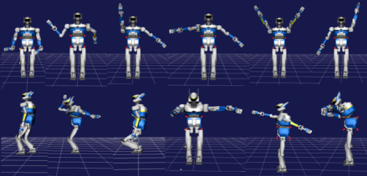  Examples of exciting trajectories used for the mass parameters estimation.

Short Biography of Jovana Jovic
Jovana Jovic finished School of Electrical Engineering, University of Belgrade, Serbia in 2006. From 2006 till 2009 she has been working as a part of research group for Biomedical Instrumentation and Technologies, Belgrade, Serbia. She received her PhD degree in automatic control and robotics in 2012 from University of Montpellier II. From 2012 till 2013 she worked as post-doc researcher in DEMAR research group at Montpellier Laboratory for Informatics, Microelectronics and Robotics (LIRMM), France. She joined the AIST JRL laboratory in 2013. Her research interests include robotics control, movement analysis, humanoid robotics, biomedical engineering, and biomechanics.

