×/× /2018

Letter of Acceptance

The 2019 International Conference on Artificial Life and Robotics (ICAROB2019)
January 10-13, 2019, B-Con Plaza, Beppu, Oita, Japan

Dear ,

Paper Title:

Authors:

Style of presentation:
Oral presentation

It is a great pleasure for me to inform you that your paper at The 2019 International Conference on Artificial Life and Robotics (ICAROB2019), which will be held at B-Con Plaza from January 10, 2019 to January 13, 2019, Beppu, Oita, Japan has been accepted for publication in the proceedings of ICAROB2019 after an extensive refereeing procedure.
I look forward to seeing you in Beppu, Oita.

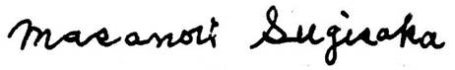

Masanori Sugisaka
General Chairman of ICAROB
President of ALife Robotics Co. Ltd.

