Co- General Chairs

Professor Yingmin Jia (Beihang University, P.R.China)

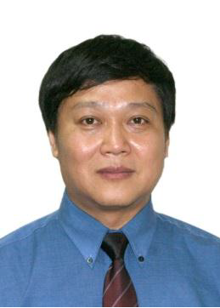

Professor Takao Ito (Hiroshima University, Japan)

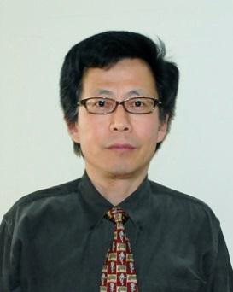

Emeritus Professor Ju-Jang Lee (KAIST, Korea)

