Notification of Acceptance
Date:
Ref No:
Title of Pape:

Author(s):
Address/Affiliation

Style of Presentation

Oral presentation
It is a great pleasure for us to inform that your paper has been accepted for presentation at The 2017 International Conference on Artificial Life and Robotics which will be held Turthday through Sunday, Jan 19-22, 2017, at Seagaia Convention Center, Miyazaki, Japan
I look forward to seeing you in Myazaki, Japan

General Chair
Masanori Sugisaka
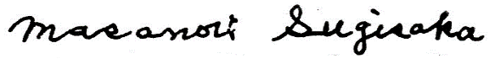
Co-General Chairs
Yingmin Jia, Takao Ito, Ju-Jang Lee
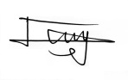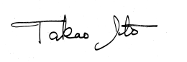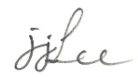
Program Chair
Mokoto Sakamoto

